**Duo Universal Prompt Project  
End-User Education Communication Templates**

Email Communication Best Practices 1

Duo Universal Prompt Project Glossary and FAQs 2

Glossary 2

Frequently Asked Questions 4

Email Templates — Introducing End-Users to the Authentication Redirect Flow 8

Email #1: Change to Duo login experience, no immediate action required. 8

Email Templates — Introducing End-Users to the Duo Universal Prompt 10

Email #1: A new Duo Prompt is coming soon, no immediate action required. 10

Email #2: A new Duo Prompt is coming on [date], no immediate action required. 12

Email #3: Reminder: A new Duo Prompt is coming on [date]. 15

# 

# Email Communication Best Practices

The [Duo Universal Prompt Playbook](https://duo.com/assets/pdf/Duo_Universal_Prompt_Playbook.pdf) provides guidance on creating a communications plan for your organization’s rollout of the Duo Universal Prompt. Duo recommends the following basic best practices when communicating with end-users over email:

* **Days to send emails:** Tuesdays, Wednesdays, and Thursdays are the best days to send emails that users will open.
* **Who to send the email from:** We recommend that emails about the Duo Universal Prompt Project come from a specific person (IT manager, Ops director, etc.) or from your help desk.
* **Include visuals where possible:** If you are describing a visual change, include an image of the change as it will appear to end-users.
* **Provide a way for users to follow up:** Be sure to include the contact information for your end-user support team to handle any questions.

# Duo Universal Prompt Project Glossary and FAQs

Here is an overview of common terminology associated with the Duo Universal Prompt Project, as well as frequently asked questions you might receive from users. Feel free to customize this glossary and FAQ for your organization.

## Glossary

**Authentication redirect flow:** A description of the login experience that end-users will encounter once a Duo-protected application is updated to be able to support the Universal Prompt. This new redirect-based authentication flow allows Duo to serve the prompt on a Duo-hosted page, moving it out of the application (e.g. iframe) itself. Until you enable the redesigned Universal Prompt, users will continue to authenticate with the traditional Duo Prompt.

***Current: Duo Prompt displayed in an iframe***

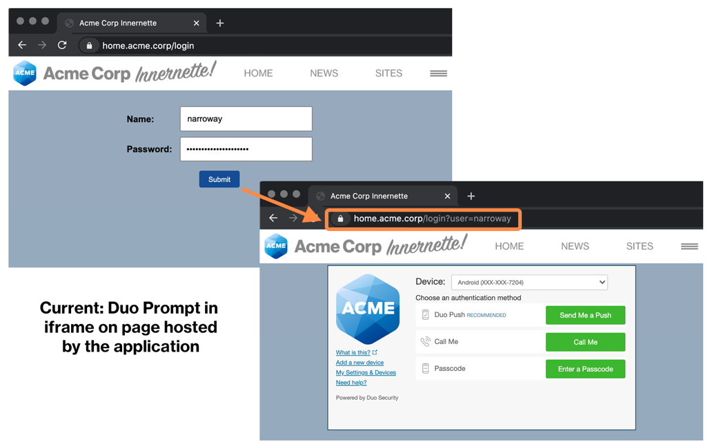

***New: Page redirect to current Duo Prompt hosted by Duo (no iframe)***

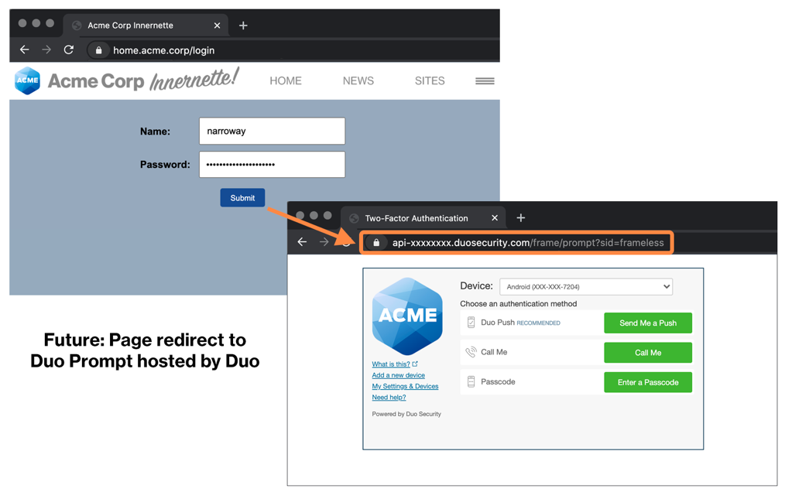

**Duo Prompt:** Duo’s web-based interactive authentication prompt. This is the UI that end-users are already familiar with. As part of the Universal Prompt Project, Duo is redesigning the prompt for supported applications. The redesigned prompt, called the Universal Prompt, will be available to enable on web-based applications that display the current Duo Prompt in browsers.

**Duo Universal Prompt:** Duo’s redesigned authentication prompt. The Universal Prompt is coming to web-based applications that display the current Duo Prompt in browsers. The Universal Prompt features an updated UI and customizable branding, as well as improved web accessibility and language support. The Universal Prompt is currently under development.

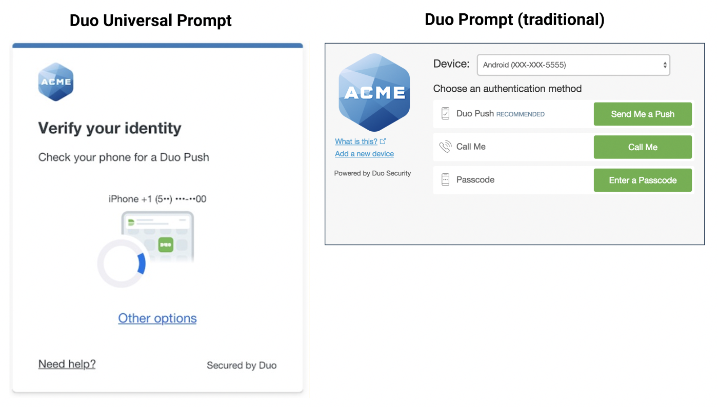

**Universal Prompt Project:** The multi-phase initiative consisting of three changes to Duo’s product: 1) a redesign of Duo’s browser-based authentication prompt; 2) a new mechanism for delivering the prompt via an authentication redirect flow that no longer relies on an iframe; and 3) a redesign of the Duo Mobile application (completed in October 2021).

## Frequently Asked Questions

Below are some key questions that end-users may have about the Universal Prompt Project. *Depending on your organization’s specific applications and rollout plan, you may wish to edit some questions or remove them.*

**Topic: Application Updates**

**Why do I see a redirect to a Duo webpage when authenticating into an application?**

Once an eligible application is updated to get it ready to support the Universal Prompt, it will display the traditional Duo Prompt on a Duo-hosted page until you enable the Universal Prompt. An end-user might notice that the prompt no longer appears in the context of an iframe wrapper. Instead, users will be redirected to a Duo-hosted page to authenticate with the prompt and then redirected back to the application they are logging into.

*Current Duo Prompt displayed in an iframe:*

*New: Page redirect to current Duo Prompt hosted by Duo (no iframe):*

#### **Topic: Universal Prompt**

**What are the differences between the traditional Duo Prompt and the new Universal Prompt?**

The Universal Prompt is a visual and technical redesign of the traditional Duo Prompt. Once it is released (or as part of a preview phase), the Universal Prompt may be used on web-based applications that display the current Duo Prompt in browsers and select thick-client applications that use single sign-on. To review which Duo 2FA offerings are **not in scope** for the Universal Prompt, refer to [our documentation](https://duo.com/docs/universal-prompt-update-guide#universal-prompt-application-scope).

End-users will likely notice four major changes when using the Universal Prompt:

1. **Last-used authentication method:** The Universal Prompt remembers a user’s last-used authentication method (e.g. Duo Push, security key, TouchID, etc.) and displays that option by default. Users will not see other available login methods until they click “Other options.”
2. **Automatic Duo Push:** Once a user lands on the Universal Prompt, it will automatically send a Duo Push to their device without needing to click a button (if they use Duo Push).
3. **Updated visual appearance:** The Universal Prompt has been visually redesigned with a simplified interface.
4. **Support for more languages:** The Universal Prompt supports English, Spanish, French, German, and Japanese. The prompt interface will use browser or OS language settings to determine a user’s preferred language.

For a comparison of the traditional Duo Prompt and the Universal Prompt, see [this Duo Knowledge Base article](https://help.duo.com/s/article/7118).

**How does an end-user access other options to log in?**

By default, the Universal Prompt displays the authentication method that the end-user most recently used. They can access other options to log in by clicking “Other options.” The last-used authentication method is browser- and application-specific and based on a stored cookie.

Note that a user may have to cancel the login request for some authentication methods, such as security key, in order to access “Other options” because most authentication methods are triggered automatically without the user needing to click a button in the prompt.

**Why do I see a “Trust browser?” prompt after I log in with the Universal Prompt?**

If a [Remembered Devices policy](https://duo.com/docs/remembered-devices#configuring-remembered-devices) is enabled by a Duo administrator, end-users will be prompted to check a box allowing their browser to be remembered for the specified period of time. In the Universal Prompt, this message will appear on a separate screen shown to users after they complete 2FA if they do not have an existing cookie indicating they previously wanted to “Trust browser.” If a user has previously elected to “Trust browser” and the cookie has expired, they will see a checkbox option on the first screen in the 2FA flow instead. This additional step is designed to encourage more users to use this feature, reducing the number of times they need to perform Duo 2FA for the set time period.

|  |  |
| --- | --- |
|  **|  **|

**How does a user add or edit a device using the self-service portal in conjunction with the Universal Prompt?**

The [self-service portal](https://duo.com/docs/self-service-portal), which must be enabled by a Duo administrator on a per-application basis, has also been redesigned as part of the Universal Prompt Project.

Users may add or edit their available devices by going to “Other options” in the Universal Prompt and then selecting “Manage devices.” From there, they will visit a page listing their current devices and be able to add or edit devices.

Note that the “Manage devices” workflow now occurs in a separate page rather than within the frame of the prompt itself, in contrast to the traditional Duo Prompt.

|  |  |
| --- | --- |
| *Select “Other options”* | *Then select “Manage devices”* |

|  |  |
| --- | --- |
| *Device management in the traditional Duo Prompt (within the frame of the prompt)* | *Device management in the Universal Prompt (a separate page)* |

# Email Templates — Introducing End-Users to the Authentication Redirect Flow

**Use this email template if your organization wishes to proactively notify users about the authentication redirect flow they will experience after you update Duo-protected applications in your environment to a version that will eventually support the Duo Universal Prompt. Customize the details to fit your environment.**

**This change may not be apparent to many of your end-users, but giving advance notice of authentication changes, even minor ones, can prevent confusion and questions to your help desk.**

**For guidance on creating a communications plan for your organization, refer to the** [**Universal Prompt Playbook**](https://duo.com/assets/pdf/Duo_Universal_Prompt_Playbook.pdf)**.**

### Email #1: Change to Duo login experience, no immediate action required.

**TIMELINE:**

At least 1 week before updating an application to the latest version that supports the authentication redirect flow that will allow you to eventually enable the Duo Universal Prompt for supported applications.

**AUDIENCE:**

End-users of the Duo-protected application(s) you are updating to support the new authentication redirect flow.

**SUBJECT LINE:**

Change to Duo login experience for [**application name(s)**]

**BODY:**

On [**date**], we will perform a back-end update to Duo Security that introduces a small change to your Duo login experience when authenticating to [**application name(s)**].

***Action required:***

No action is required on your part. This email is to notify you of the change, which will occur on [**date of update**].

***What is changing?***

After this update, you may notice a minor difference when you log in using the Duo Prompt. This change only affects [**application name(s)**].

After you enter your primary credentials to log in to the application, you will see your browser perform a quick redirect to a plain white Duo-hosted page that displays the Duo Prompt.

The URL of the Duo-hosted page will begin with api-[**your API hostname here**].duosecurity.com.

Here is an illustration of how the Duo Prompt will appear after this change, showing the redirect to a URL beginning with api- and a plain white background behind the prompt.

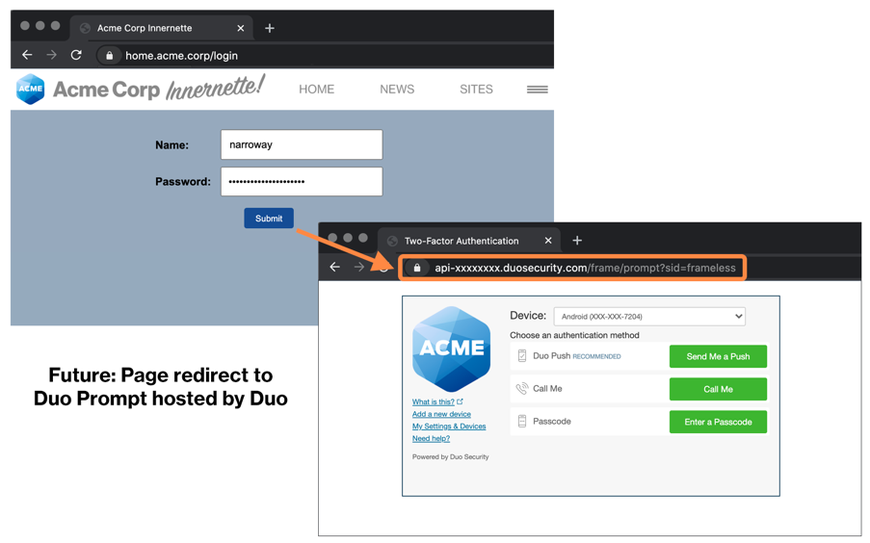

You will complete two-factor authentication with the Duo Prompt like normal. After you successfully complete two-factor authentication, you will be automatically redirected back to the application you are logging into.

*Questions?*

Please reach out to the [**Help Desk/Service Desk**] with any questions about this change.

Phone: [**xxxx**]

Email: [**xxxx**]

# Email Templates — Introducing End-Users to the Duo Universal Prompt

**Use these email templates if your organization is rolling out the redesigned authentication prompt, the Duo Universal Prompt. Customize the details to fit your environment.**

**For guidance on creating a communications plan for your organization, refer to the** [**Universal Prompt Playbook**](https://duo.com/assets/pdf/Duo_Universal_Prompt_Playbook.pdf)**.**

### Email #1: A new Duo Prompt is coming soon, no immediate action required.

**TIMELINE:**

At least 30 to 60 days before you enable the Universal Prompt for one or more of your Duo-protected applications.

**AUDIENCE:**

End-users of the Duo-protected applications you are updating to use the Universal Prompt.

**SUBJECT LINE:**

A new look for Duo is coming soon!

**BODY:**

In the next few weeks, you will see a new look for Duo Security when we roll out a redesigned Duo authentication prompt for the following applications:

* **[application name(s)]**

***Action required:***

No action is required on your part. This email is to notify you of the upcoming changes to the Duo user interface (UI) and let you know what to expect.

***What is changing?***

Duo is introducing a redesigned authentication prompt, called the Duo Universal Prompt. This is the user interface you see when you perform two-factor authentication on many of our applications.

The redesigned prompt will appear on the following applications:

* **[application name(s)]**

[**Depending on the applications in your environment, you may wish to include:** You will continue to see the traditional Duo Prompt on other applications.]

The updated authentication prompt is designed to provide a streamlined authentication experience that feels simple and fast. Here are the **four major changes** you can expect to see in the Duo Universal Prompt:

1. **Last-used authentication method:** The Universal Prompt remembers your last-used authentication method (e.g. Duo Push, security key, TouchID, etc.) and displays that option by default. You will not see other available login methods until you click “Other options.”
2. **Automatic Duo Push:** Once you land on the Universal Prompt, it will automatically send a Duo Push to your device without needing to click a button (if you use Duo Push).
3. **Updated visual appearance:** The Universal Prompt has been visually redesigned with a simplified interface.
4. **Support for more languages:** The Universal Prompt supports English, Spanish, French, German, and Japanese. The prompt interface will use your browser or OS language settings to determine your preferred language.

**[If your organization uses the Duo self-service portal for device management, you may wish to include the following section and screenshots]**

As part of the launch of the Duo Universal Prompt, you will also notice changes when you add a new device or update an existing device you use with Duo.

To manage your devices, go to “Other options” in the Universal Prompt and then select “Manage devices.” From there, you will visit a page listing your current devices and be able to add or edit devices.

|  |  |
| --- | --- |
|   *Select “Other options”* |   *Then select “Manage devices”* |

***When the Duo Universal Prompt launches, will I need to do anything?***

No. If you are enrolled in Duo today, you will **not** need to re-enroll or change any Duo settings when the new prompt launches.

***More information coming soon.***

We will let you know when the redesigned Duo prompt will launch.

***Questions?***

Contact our [**help desk / service desk**] with any questions about the Duo Universal Prompt.

[Help desk / service desk] **Phone number:**

[Help desk / service desk] **Email:**

[Help desk / service desk] **Submit a help request:**

### Email #2: A new Duo Prompt is coming on [date], no immediate action required.

**TIMELINE:**

At least 2 weeks to 30 days before you enable the Universal Prompt for one or more of your Duo-protected applications.

**AUDIENCE:**

End-users of the Duo-protected applications you are updating to use the Universal Prompt.

**SUBJECT LINE:**

A new look for Duo is coming on [**date**]!

**BODY:**

Beginning on [**date**], you will see a new look for Duo Security when we roll out a redesigned Duo authentication prompt for the following applications:

* **[application name(s)]**

***Action required:***

No action is required on your part. This email is to notify you of the upcoming changes to the Duo user interface (UI) and let you know what to expect.

***What is changing?***

Duo is introducing a redesigned authentication prompt, called the Duo Universal Prompt. This is the user interface you see when you perform two-factor authentication on many of our applications.

The redesigned prompt will appear on the following applications:

* **[application name(s)]**

[**Depending on the applications in your environment, you may wish to include:** You will continue to see the traditional Duo Prompt on other applications.]

The updated authentication prompt is designed to provide a streamlined authentication experience that feels simple and fast. Here are the **four major changes** you can expect to see in the Duo Universal Prompt:

1. **Last-used authentication method:** The Universal Prompt remembers your last-used authentication method (e.g. Duo Push, security key, TouchID, etc.) and displays that option by default. You will not see other available login methods until you click “Other options.”
2. **Automatic Duo Push:** Once you land on the Universal Prompt, it will automatically send a Duo Push to your device without needing to click a button (if you use Duo Push).
3. **Updated visual appearance:** The Universal Prompt has been visually redesigned with a simplified interface.
4. **Support for more languages:** The Universal Prompt supports English, Spanish, French, German, and Japanese. The prompt interface will use your browser or OS language settings to determine your preferred language.

**[If your organization uses the Duo self-service portal for device management, you may wish to include the following section and screenshots]**

As part of the launch of the Duo Universal Prompt, you will also notice changes when you add a new device or update an existing device you use with Duo.

To manage your devices, go to “Other options” in the Universal Prompt and then select “Manage devices.” From there, you will visit a page listing your current devices and be able to add or edit devices.

|  |  |
| --- | --- |
| *Select “Other options”* |   *Then select “Manage devices”* |

***When the Duo Universal Prompt launches, will I need to do anything?***

No. If you are enrolled in Duo today, you will **not** need to re-enroll or change any Duo settings when the new prompt launches.

***Questions?***

Contact our [**help desk / service desk**] with any questions about the Duo Universal Prompt. You can also find a users guide to the Universal Prompt at <https://guide.duo.com/universal-prompt>.

[Help desk / service desk] **Phone number:**

[Help desk / service desk] **Email:**

[Help desk / service desk] **Submit a help request:**

### 

### Email #3: Reminder: A new Duo Prompt is coming on [date].

**TIMELINE:**

The week you plan to enable the Universal Prompt for one or more of your Duo-protected applications.

**AUDIENCE:**

End-users of the Duo-protected applications you are updating to use the Universal Prompt.

**SUBJECT LINE:**

A new look for Duo is coming this week!

**BODY:**

Beginning on [**date**], you will see a new look for Duo Security when we roll out a redesigned Duo authentication prompt for the following applications:

* **[application name(s)]**

***Action required:***

No action is required on your part. This email is to notify you of the upcoming changes to the Duo user interface (UI) and let you know what to expect.

***What is changing?***

Duo is introducing a redesigned authentication prompt, called the Duo Universal Prompt. This is the user interface you see when you perform two-factor authentication on many of our applications. 

The redesigned prompt will appear on the following applications:

* **[application name(s)]**

[**Depending on the applications in your environment, you may wish to include:** You will continue to see the traditional Duo Prompt on other applications.]

The updated authentication prompt is designed to provide a streamlined authentication experience that feels simple and fast. Here are the **four major changes** you can expect to see in the Duo Universal Prompt:

1. **Last-used authentication method:** The Universal Prompt remembers your last-used authentication method (e.g. Duo Push, security key, TouchID, etc.) and displays that option by default. You will not see other available login methods until you click “Other options.”
2. **Automatic Duo Push:** Once you land on the Universal Prompt, it will automatically send a Duo Push to your device without needing to click a button (if you use Duo Push).
3. **Updated visual appearance:** The Universal Prompt has been visually redesigned with a simplified interface.
4. **Support for more languages:** The Universal Prompt supports English, Spanish, French, German, and Japanese. The prompt interface will use your browser language settings to determine your preferred language.

**[If your organization uses the Duo self-service portal for device management, you may wish to include the following section and screenshots]**

As part of the launch of the Duo Universal Prompt, you will also notice changes when you add a new device or update an existing device you use with Duo.

To manage your devices, go to “Other options” in the Universal Prompt and then select “Manage devices.” From there, you will visit a page listing your current devices and be able to add or edit devices.

|  |  |
| --- | --- |
|   *Select “Other options”* |   *Then select “Manage devices”* |

***When the Duo Universal Prompt launches, will I need to do anything?***

No. If you are enrolled in Duo today, you will **not** need to re-enroll or change any Duo settings when the new prompt launches.

***Questions?***

Contact our [**help desk / service desk**] with any questions about the Duo Universal Prompt. You can also find a users guide to the Universal Prompt at <https://guide.duo.com/universal-prompt>.

[Help desk / service desk] **Phone number:**

[Help desk / service desk] **Email:**

[Help desk / service desk] **Submit a help request:**